Name : Subashini S

NM id : au621421106050

**Air quality monitoring (IoT)**

Air quality monitoring using IoT involves the use of commercially available software and hardware to monitor indoor air quality (IAQ).

An IoT-based indoor air quality monitoring platform called “Smart-Air” has been developed, which relies on IoT and cloud computing technology to monitor indoor air quality.

The data of all the gas sensors used for measuring gases in the air is fed to the microcontroller for analysis, and it results in the Pollution level in PPM (parts per million).

**Diagram:**

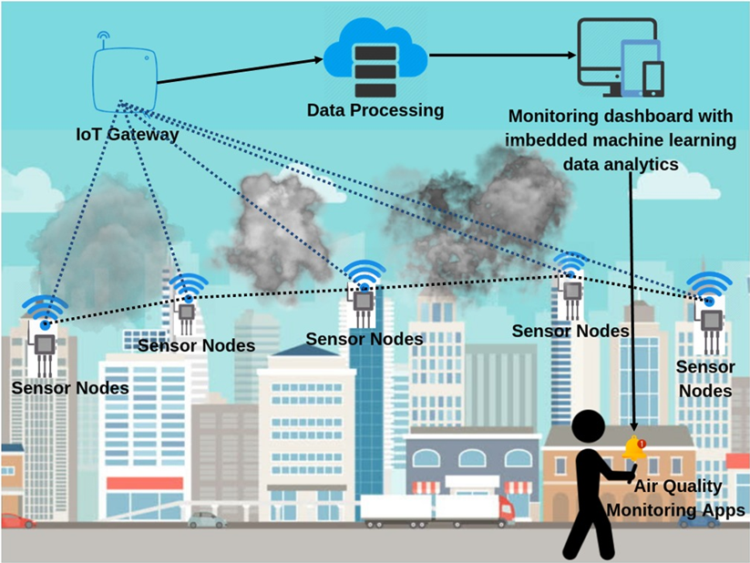

**Program:**

Creating a complete air quality monitoring system is a complex task that typically involves hardware components like sensors and data collection devices. However, I can provide you with a simple Python script that can fetch air quality data from an online API and display it. This script uses the AirVisual API as an example, but you can adapt it to work with other APIs or local sensors as needed.

import requests

# Replace with your AirVisual API key

API_KEY = 'YOUR_API_KEY'

def get_air_quality_data():

try:

url = f'https://api.airvisual.com/v2/nearest_city?key={API_KEY}'

response = requests.get(url)

data = response.json()

return data

except Exception as e:

print(f"Error fetching air quality data: {e}")

return None

def display_air_quality(data):

if data:

city = data['data']['city']

state = data['data']['state']

aqi = data['data']['current']['pollution']['aqius']

main_pollutant = data['data']['current']['pollution']['mainus']

print(f'Air Quality in {city}, {state}')

print(f'Air Quality Index (AQI): {aqi}')

print(f'Main Pollutant: {main_pollutant}')

else:

print('No data available.')

if __name__ == '__main__':

air_quality_data = get_air_quality_data()

display_air_quality(air_quality_data)

Please note that this script fetches air quality data for the nearest city using the AirVisual API. You can customize it further to suit your needs, such as fetching data for a specific location, storing data over time, or integrating it with other services or hardware sensors.